## **RAM (Random Access Memory) Types**

RAM is the computer’s **temporary memory**, used while the system is running. Data in RAM is erased when the power is turned off.

### **Main Types:**

**# SRAM (Static RAM)**

* + Faster, more expensive.
  + Used in CPU caches.
  + Stores data using flip-flops (retains data as long as powered).
* **DRAM (Dynamic RAM)**
  + Slower, cheaper, used as main system memory.
  + Stores data using capacitors, needs refreshing thousands of times per second.
* Under DRAM, we have:  
  + **SDRAM (Synchronous DRAM)** – Syncs with CPU clock, faster than plain DRAM.
  + **DDR SDRAM (Double Data Rate SDRAM)** – Transfers data on both rising & falling edges of clock. Generations include:  
    - **DDR1, DDR2, DDR3, DDR4, DDR5** – Each newer version is faster and uses less power.
    - Example: DDR4 is common in most PCs today, DDR5 in newer systems.
    - **Storage Devices – Differences**

Storage is **permanent memory**, unlike RAM.

### **Types:**

* **HDD (Hard Disk Drive)**
  + Mechanical spinning disks.
  + Large capacity (1TB+), cheaper.
  + Slower (100–200 MB/s typical).
* **SSD (Solid State Drive)**
  + No moving parts; uses flash memory.
  + Much faster (500 MB/s to several GB/s).
  + More expensive per GB.
* **NVMe SSD** (connected via PCIe instead of SATA)  
  + Very high speeds (up to 7000 MB/s).
  + Common in modern laptops/desktops.
* **Optical Discs (CD/DVD/Blu-ray)**
  + Use laser technology.
  + Mostly obsolete now except in archives/media.
* **Flash Drives & Memory Cards**
  + Portable, smaller capacity.
  + Convenient but less durable than SSDs.

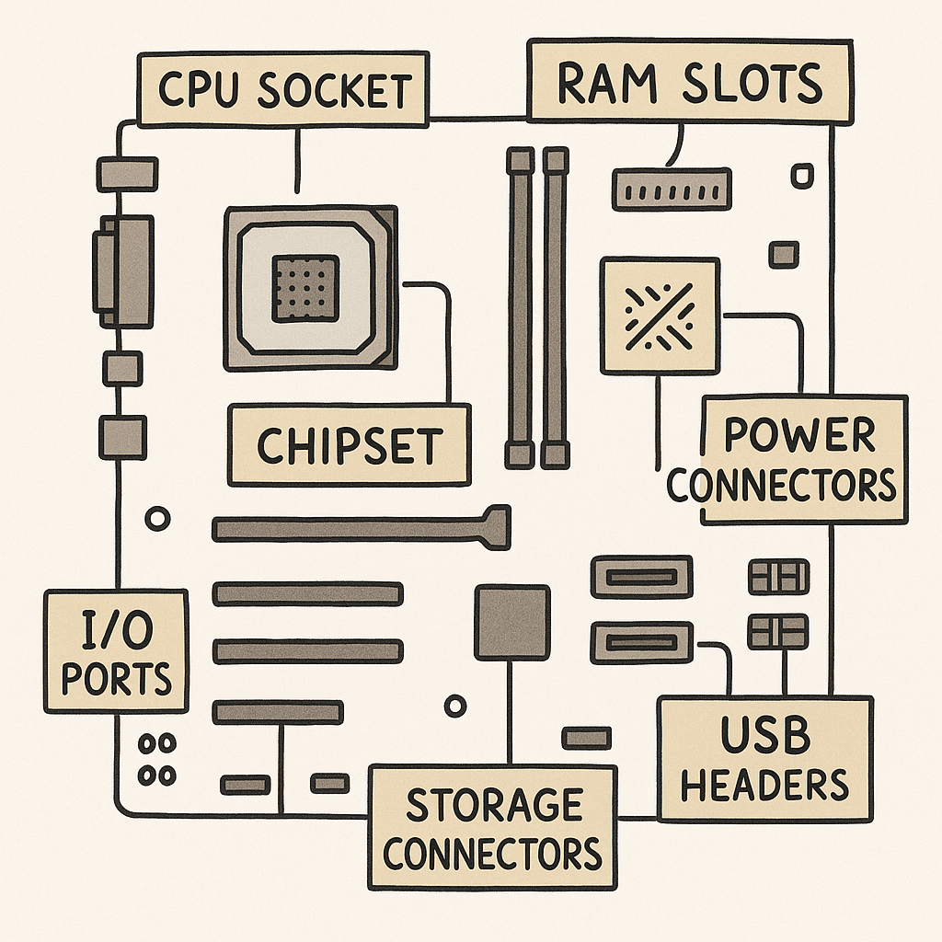 Created with Imageeditor

## 

## 

## 

## **Key:**

* **CPU Socket** – where the processor is installed.
* **RAM Slots (DIMM slots)** – for system memory.
* **Chipset** – manages communication between CPU, RAM, and peripherals.
* **Power Connectors** – main ATX power (24-pin), CPU power (4/8-pin).
* **PCIe Slots** – for graphics cards, sound cards, etc.
* **Storage Connectors** – SATA ports for HDD/SSD, M.2 slots for NVMe SSDs.
* **USB Headers** – connect to case USB ports.
* **I/O Ports (back panel)** – USB, HDMI, audio, Ethernet.
* **BIOS/UEFI Chip** – stores firmware settings.